**Number of Questions — 2**

**Percent of total test grade — 50**

**Directions:** Please complete the following program according to the specification given. Partial credit will be given for incomplete answers, so provide as much of the answer as you can.  
  
Remember that all program segments are to be written in Java.

**GO ON TO THE NEXT PAGE.**

1. Consider the following program output:  
     
   ¸.·´¯`·.¸¸ ><((((º> ¸.·´¯`·.¸¸ ><((((º>  
   ><((((º> ¸.·´¯`·.¸¸ ><((((º>  
     
   Fill in the blanks in the following program so that it correctly produces the above output. You must not leave any blanks empty. You might need to add several statements above a blank line to produce the correct output.  
     
   public class FishInAStream {  
     
    _______________________ drawWater() {  
     
     
    System.out.print(_____________________);  
    }  
     
    _______________________ drawFish() {  
     
     
    _____________________  
    }  
     
    public static void main(String[] args) {  
     
     
     
     
     
     
     
     
    __________________________________  
    }  
   }

**GO ON TO THE NEXT PAGE.**

1. Write a structured program (a program that uses method calls) that outputs the lyrics to "Los hombres no lloran" by the Voodoo Glow Skulls:

Los hombres no lloran.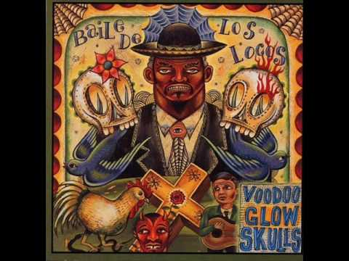

Los hombres no lloran.

Huh!

Los hombres no lloran.

Los hombres no lloran.

Huh!

Ha ha ha ha!

Los hombres no lloran.

Huh!

Your program should include only one (únicamente uno) statement that looks like:

System.out.println("Los hombres no lloran.");

Write your complete program on the following page.

**GO ON TO THE NEXT PAGE.**

**END OF SECTION II.**